**Lab Report**

**LTSpice Experiment - II**

Name: Ajay Choudhury Roll no.: 18018 Date: 18th Feb 2021

1. **Inverter Amplifier Using OP-AMP**

**Aim**: Design an Inverting Amplifier using OP-AMP and observe the gain for different input

Waveforms.

**Theory**: An Inverting Amplifier using OP-AMP is a type of amplifier with an output 180 degree

out of phase to the input waveform. The input waveform is amplified by a factor AV and its phase

will be opposite.

AV is known as the Open-loop gain of the amplifier. In an inverting amplifier,

the input to be amplified is applied to the inverting terminal of OP-AMP through a resistor R1.

Rf is the feedback resistor. Rf and R1 together determine the gain of the amplifier.

RL is the load resistor and amplified output can be observed across it. Based on the values of Rf and R1, one can decide the gain of the amplifier which will, in turn, decide the peak amplitude

of the output waveform.

**Circuit Diagram:**

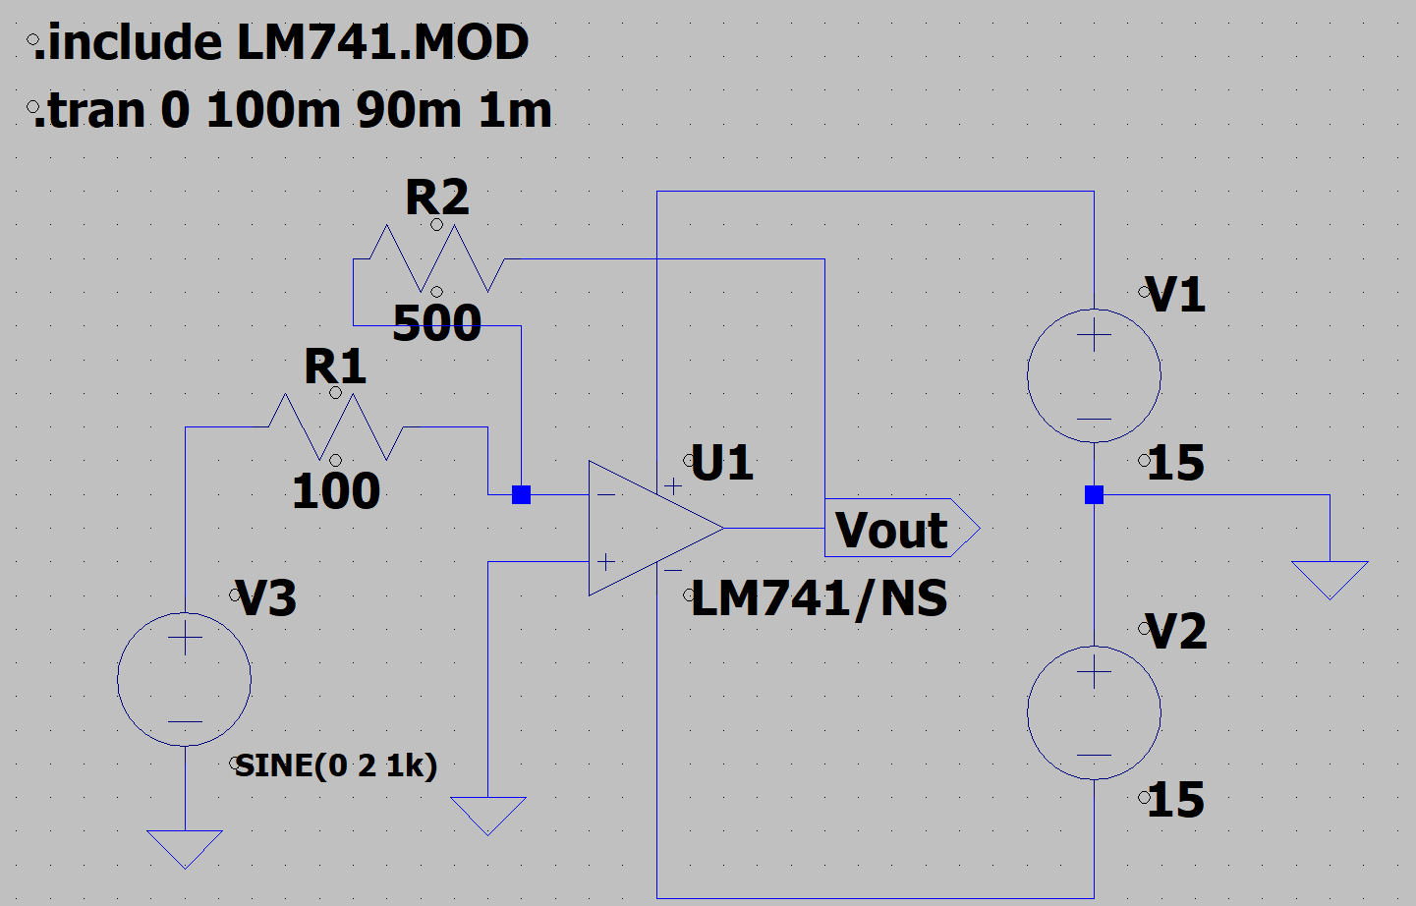

**Output:**

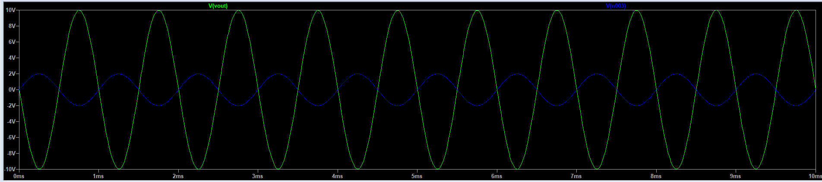

**Gain:**

Here, AV = -5.

1. **Non-Inverting Amplifier Using OP-Amp**

**Aim**: Design a Non-inverting Amplifier using OP-AMP and observe the gain for different input

Waveforms.

**Theory**: In this configuration, the input signal (Vin) is applied to the non-inverting terminal of an

OP-AMP, which means the output waveform will be in phase with the input waveform. In this

case, Rf and R1 make a voltage divider circuit and a small part of the output voltage is fed back

to the input terminal. Due to this negative feedback, this closed-loop configuration provides

good stability compared to the inverting amplifier.

Based on the values of Rf and R1, one can decide the gain of the amplifier to get the desired

The peak amplitude of the output waveform.

**Circuit diagram:**

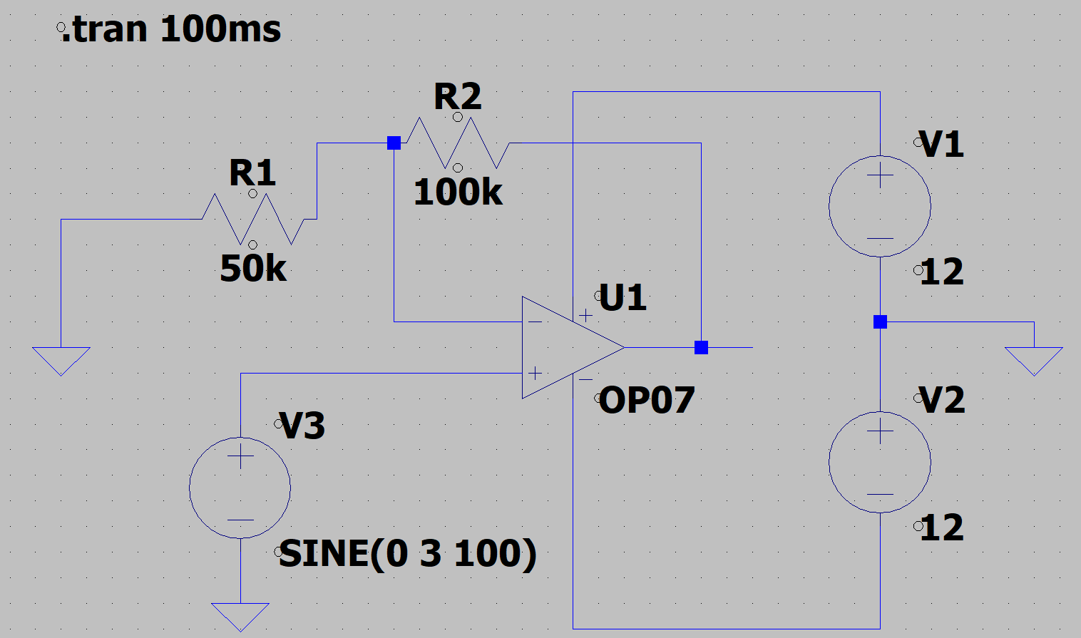

**Output:**

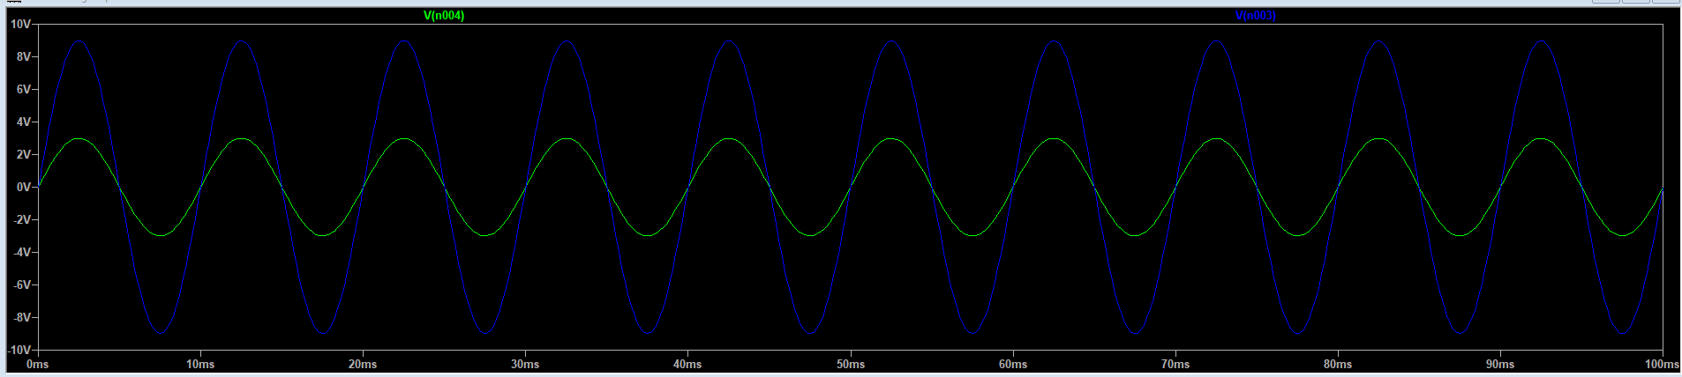

**Gain:**

Here, gain = 1 + RF/R1

Or, AV = 3

1. **Integrator Using OP-AMP**

**Aim**: Design an active integrator and plot the output waveform at different levels of the input

Voltage.

**Theory:** Operational amplifiers can be used as part of a positive or negative feedback amplifier or as an adder or subtractor type circuit using just pure resistances in both the input and the feedback loop.

But what if we were to change the purely resistive ( Rƒ ) feedback element of an inverting amplifier with a frequency-dependent complex element that has a reactance, ( X ), such as a Capacitor, C.

By replacing this feedback resistance with a capacitor, we now have an RC Network connected across the operational amplifier feedback path, producing another operational amplifier circuit commonly called an Op-amp Integrator circuit.

**Circuit diagram:**

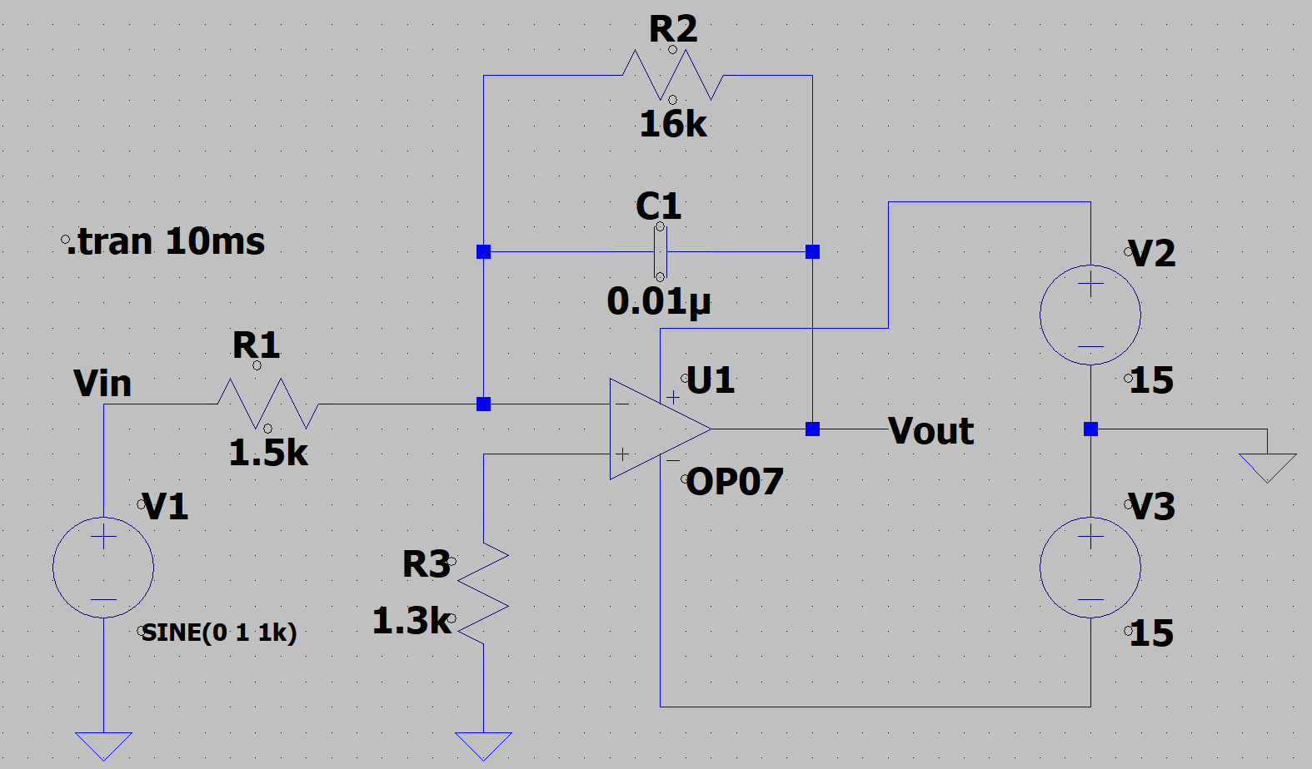

**Output:**

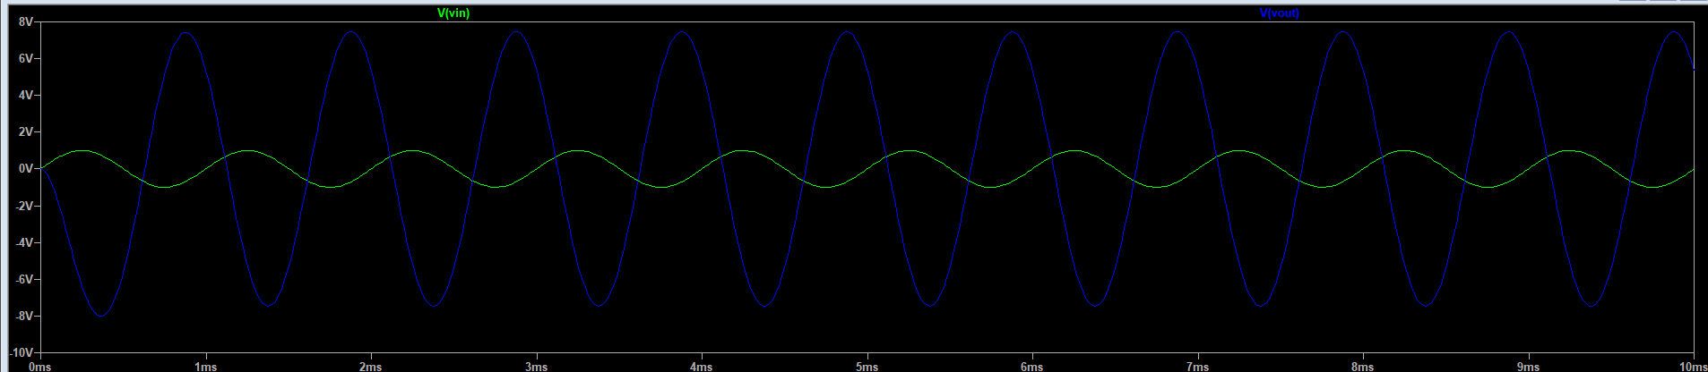

1. **Differentiator using OP-AMP**

**Aim:** Design an active differentiator and plot the output waveform at different levels of the

input voltage.

**Theory:** A differentiator circuit may be obtained by replacing the capacitor with an inductor in Fig. 3

for an integrator. In practice, this is rarely done since inductors are expensive, bulky and

inefficient devices. The circuit diagram below shows a fundamental differentiator circuit constructed with a capacitor and a resistor.

For an ideal op-amp, the current flowing through the capacitor is equal to the current flowing

through the resistor. The output is thus proportional to the derivative of the input.

As the integrator is sensitive to DC drifts, the differentiator is sensitive to high-frequency noise.

The differentiator thus is a great way to search for transients but will add noise. However, an

integrator will decrease noise.

**Circuit diagram:**

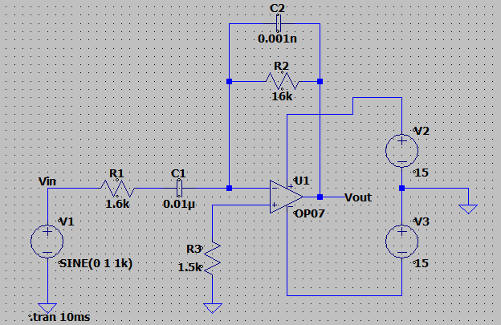

**Output:**

